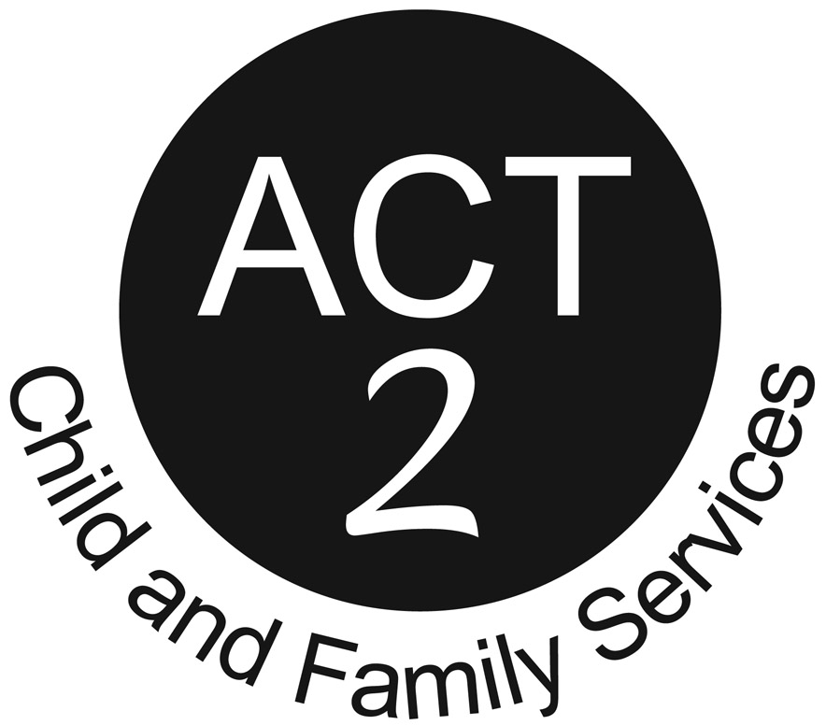
SAIP COUNSELLING (Sexual Abuse Intervention Program)
1034 Austin Ave., 2nd Floor, Coquitlam, BC V3K 3P3 Tel: 604.937.7776 Fax: .604.937.7334
203-11743 224th Street, Maple Ridge, B.C. V2X 6A4 Tel: 604.463.0965 Fax: 604.463.2416

SELF-REFERRAL FORM
(For children and youth 18 y/o and under living in the Ridge Meadows or Tri-Cities communities)
Referral Date:
Who referred you or how did you find us:
Client Name: D.O.B. _____________________Age:
Gender: _______________ Pronouns: ___________________ Indigenous: Yes No
Person completing this form: Relation to client: ______
Name of Legal Guardian: ______________________ Is he/she aware of this referral? Yes No
If no, please indicate reason: _________________________________________________________
Address:
City: _________________________________________________ Postal Code:
Home Phone: Is it OK to leave message? Yes No
Other Phone: Email: _____
If counselling is being requested for a child of separated or divorced biological parents, please complete the following 3 questions: N/A
- Who has signing authority for the referred child(ren):

- Is a court order available? Yes No Unsure N/A

- Are Child Custody or Access Issues Present? Yes No If yes, please explain:

Has this incident been reported? Yes No Unsure N/A

OVER TO PAGE 2 …

Please briefly indicate the purpose of counselling and any other information you feel comfortable providing to us in relation to the concerns identified:
________________________________________________________________________________________________________________________________________________________________________________________________________________________________________________
________________________________________________________________________________________________________________________________________________________________________________________________________________________________________________
________________________________________________________________________________________________________________________________________________________________________________________________________________________________________________
________________________________________________________________________________________________________________________________________________________________________________________________________________________________________________
________________________________________________________________________________________________________________________________________________________________________________________________________________________________________________
________________________________________________________________________________
Once ACT 2 receives this completed form, a counsellor will reach out to you via the phone number(s) provided to set up an appointment for intake, followed by regularly scheduled weekly sessions on a day and time that works for both the client and counsellor.
The length of service for this self-referral counselling program is up to nine months.
Thank you.

